KIGALI INDEPENDENT UNIVERSITY
MASTER OF SCIENCE IN SOFTWARE ENGINEERING
SCHOOL OF SCIENCE AND TECHNOLOGY
P.o Box 2280 Kigali

Module: Advanced Database Design and implementation
FINAL EXAM
Names: ABAKAR SIDICK BABA ABAKAR ALI
Roll Number: 202540413

Date : 08/03/2026
SECTION A - COMPULSORY
a. Differences between Document Databases and Wide-Column Databases (4 marks)
Aspect | MongoDB (Document) | HBase (Wide-Column)
Data Model | Stores data as JSON/BSON documents | Stores data in column families with rows and columns
Structure | Self-contained documents with key-value pairs | Tables with row keys, column families, and columns
Nested Data | NATURALLY supports nested arrays and objects | Must flatten data or use complex serialization
Query Pattern | Flexible queries with aggregation pipeline | Optimized for key-based scans and lookups
Best For | Complex, hierarchical, varied data | Time-series, sparse data, high write throughput
Example | Transaction with embedded items: | User session with column families:
 | json |
 | { | Row key: user_001_20250308
 | "txn_id": "T100", | Column Family: 'session:'
 | "items": [ | session:id = sess_123
 | {"prod":"A","qty":2}, | session:device = mobile
 | {"prod":"B","qty":1} | Column Family: 'page_views:'
 | ] | page_views:view_0 = home_10s
 | } | page_views:view_1 = product_45s
 |  | ``` |
Key Point :
- MongoDB = Document = Everything in ONE place (like a folder with all papers inside)
- HBase = Wide-Column = Organized in families (like filing cabinet with labeled drawers)

b. Advantages of Apache Spark for Large-Scale E-commerce
- In-Memory Processing
  - Keeps data in RAM instead of reading from disk repeatedly
  - Makes analytics 10-100x faster than traditional Hadoop
- Distributed Computing
  - Splits work across multiple computers automatically
  - Can process millions of sessions and transactions in parallel
- Unified Analytics
  - One platform for batch processing, SQL, streaming, and machine learning
  - Can join data from MongoDB and HBase in a single query
- Spark SQL
  - Write normal SQL queries that run on BIG data
  - Business analysts can use familiar syntax
- Fault Tolerance
  - If a computer fails, Spark automatically recomputes lost data
  - No data loss during long-running analytics
Example:
-- This query runs across 100 computers at once!
SELECT product_id, SUM(quantity) as total_sold
FROM transactions
GROUP BY product_id
ORDER BY total_sold DESC

c. Why NoSQL Databases for Big Data in E-commerce
Reason | Explanation
Scalability | NoSQL databases scale HORIZONTALLY (add more servers) vs SQL scales VERTICALLY (bigger server). E-commerce needs to handle millions of users.
Flexible Schema | Products have different attributes (clothes have size, electronics have voltage). NoSQL handles this without altering tables.
High Write Throughput | E-commerce generates massive data: user clicks, page views, searches. NoSQL handles millions of writes per second.
Variety of Data Types | E-commerce has structured (transactions), semi-structured (sessions), and unstructured (reviews). NoSQL handles all.
Always-On Availability | NoSQL databases are designed for 24/7 operation with no downtime.
Cost-Effective | Runs on commodity hardware (cheap servers) instead of expensive specialized hardware.
Real Example:
- Amazon processes millions of clicks per second
- Cannot use one giant SQL database - too slow and expensive
- Uses multiple NoSQL databases for different purposes

SECTION B - Data Modeling and Database Design
  - MongoDB Document Schema for Transactions
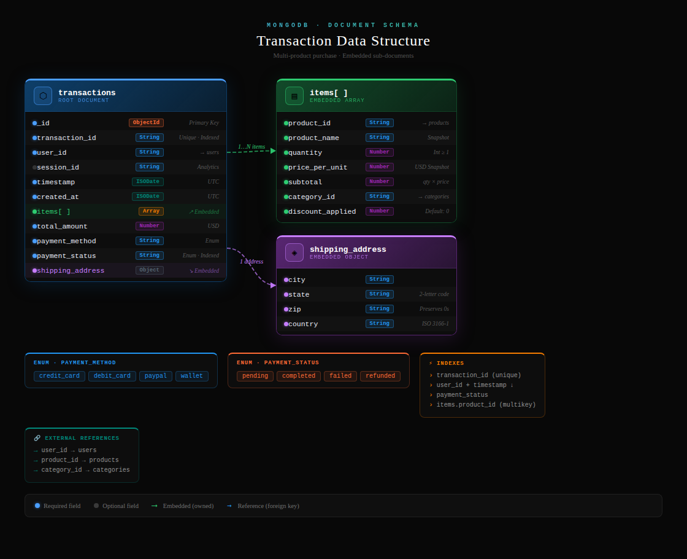
{
"_id": ObjectId("..."),
"transaction_id": "TXN123456789",
"user_id": "user_000652",
"timestamp": ISODate("2025-12-20T14:52:41Z"),
"session_id": "sess_a7b3c9d8e2",

"items": [
{
"product_id": "prod_00279",
"product_name": "Devolved 3rdgeneration time-frame",
"quantity": 2,
"price_per_unit": 186.23,
"subtotal": 372.46,
"category_id": "cat_010",
"discount_applied": 0
},
{
"product_id": "prod_00166",
"product_name": "Enhanced hybrid software",
"quantity": 1,
"price_per_unit": 382.34,
"subtotal": 382.34,
"category_id": "cat_015",
"discount_applied": 0
}
],

"total_amount": 754.80,
"payment_method": "credit_card",
"payment_status": "completed",
"shipping_address": {
"city": "Austin",
"state": "TX",
"zip": "78701",
"country": "US"
},
"created_at": ISODate("2025-12-20T14:52:41Z")
}
Why I designed it this way:
1. Embedded items array Transactions and their products are always read together, so embedding avoids unnecessary joins and gives the full transaction in a single query.
2. Historical accuracy Prices and product names are saved as snapshots inside the transaction. If a product price changes later, the original purchase record stays intact.
3. Denormalized product names Stored directly in the document so you don't need to look up the products collection every time you display an order.
4. Embedded shipping address Each transaction owns its delivery address as a snapshot, since the customer might change their address later but the original delivery location must be preserved.
5. References for users and categories user_id and category_id are kept as references (not embedded) because they are shared across many documents and updated independently.
6. MongoDB design principle "Data that is accessed together should be stored together." This schema follows that rule by keeping everything needed to display or process a transaction inside one single document.
Key Design Decisions:
- Embedded items array - all products in one transaction stored together
- Denormalized product data - preserves price at time of purchase
- Nested shipping address - address belongs to transaction
- All relevant data in ONE document - no joins needed!
B. HBase Table Design for user Browsing Sessions
Table Name: user_sessions
Row Key Desing:
row_key = user_id + "_" + reverse_timestamp
where reverse_timestamp = 99999999999999 - actual_timestamp_ms

Component | Purpose
user_id prefix | Groups all sessions for one user together
reverse_timestamp | Most recent sessions appear FIRST when scanning
Column Families:
Column Family | Columns | Description
session: | session:id | Unique session identifier
 | session:device | mobile/desktop/tablet
 | session:referrer | direct/search/social
 | session:start_time | When session started
 | session:end_time | When session ended
 | session:status | converted/abandoned/bounce
The session recorded 3 page views (home → product → cart) with time spent on each page, and a cart with 2 products (product_123 and product_456), storing quantity, unit price, and total cart value per session
Example Row:
Row Key: user_000652_99999999991234
session:id = sess_a7b3c9d8e2
session:device = mobile
session:status = converted
page_views:view_0 = home_12s
page_views:view_1 = product_45s
page_views:view_2 = cart_30s
page_views:view_3 = checkout_60s
cart:product_00279 = qty:2,price:186.23
cart:total = 372.46

  - Advantages of Embedding Product Items Inside Transaction Documents
Advantage | Explanation
1. No Joins Required | All transaction data in ONE document - faster reads
2. Historical Accuracy | Preserves product price at time of purchase (even if price changes later)
3. Atomic Operations | Update entire transaction at once - no consistency issues
4. Better Performance | One disk seek per transaction instead of multiple
5. Simpler Queries | db.transactions.find({}) gets everything - no complex joins
6. Natural Data Model | Matches real-world: one receipt contains multiple items
Example:
// WITHOUT embedding - need 3 collections!
transactions collection
items collection
products collection

// WITH embedding - ONE collection!
transactions collection with items inside
“Embedding items in transactions is like a physical receipt - one piece of paper lists all items bought. MongoDB stores it exactly that way, naturally."

d. Modeling Product Categories and Subcategories in MongoDB
Approach 1: Tree Structure with Parent Reference
{
"category_id": "cat_006",
"name": "Electronics",
"description": "Electronic devices and accessories",
"parent_category": null,
"path": "/electronics",
"level": 1
}

{
"category_id": "cat_006_01",
"name": "Smartphones",
"description": "Mobile phones",
"parent_category": "cat_006",
"path": "/electronics/smartphones",
"level": 2
}

{
"category_id": "cat_006_01_01",
"name": "Android Phones",
"description": "Phones running Android OS",
"parent_category": "cat_006_01",
"path": "/electronics/smartphones/android",
"level": 3
}
Approach 2: Embedded Subcategories Array
{
"category_id": "cat_006",
"name": "Electronics",
"subcategories": [
{
"subcategory_id": "sub_006_01",
"name": "Smartphones",
"description": "Mobile phones",
"products_count": 45
},
{
"subcategory_id": "sub_006_02",
"name": "Laptops",
"description": "Portable computers",
"products_count": 32
}
]
}

Approach 3: Materialized Path (Best for queries)
{
"category_id": "sub_006_01_01",
"name": "Samsung Galaxy",
"path": "electronics.smartphones.android.samsung",
"ancestors": ["cat_006", "cat_006_01", "cat_006_01_01"]
}
‘’I used parent references for flexibility. To get all subcategories, I can query where parent_category = category_id. This handles any depth of hierarchy."

SECTION C - Data Processing and Analytics
a. PySpark Code for Top-Selling Products
from pyspark.sql import SparkSession
from pyspark.sql.functions import col, sum, desc
Step 1: Create Spark Session
spark = SparkSession.builder \
.appName("Top Selling Products") \
.getOrCreate()

Step 2: Load transaction data
transactions_df = spark.read.json("transactions.json")

Step 3: Explode the items array (like MongoDB $unwind)
from pyspark.sql.functions import explode

items_df = transactions_df \
.select(explode("items").alias("item"))

Step 4: Calculate top products
top_products = items_df \
.groupBy("item.product_id") \
.agg(
sum("item.quantity").alias("total_quantity"),
sum("item.subtotal").alias("total_revenue")
) \
.orderBy(desc("total_revenue")) \
.limit(10)

Step 5: Show results
top_products.show()

Alternative: Using Spark SQL (easier!)
transactions_df.createOrReplaceTempView("transactions")

spark.sql("""
SELECT
item.product_id,
SUM(item.quantity) as total_quantity,
SUM(item.subtotal) as total_revenue
FROM (
SELECT explode(items) as item
FROM transactions
)
GROUP BY item.product_id
ORDER BY total_revenue DESC
LIMIT 10
""").show()
Explanation:
- Create SparkSession - entry point to Spark
- Load data - read JSON into DataFrame
- Explode - flatten the items array (like MongoDB $unwind)
- GroupBy + Aggregate - calculate totals per product
- Order + Limit - get top 10
- Show - display results
b. Using Spark SQL for Analytical Queries
What is Spark SQL?
- Write normal SQL queries that run on distributed data
- DataFrames registered as temporary views
- Supports all standard SQL: SELECT, JOIN, GROUP BY, WHERE, etc.
Example 1: Monthly Revenue Trend
Register view
transactions_df.createOrReplaceTempView("transactions")

Run SQL
monthly_revenue = spark.sql("""
SELECT
DATE_FORMAT(TO_DATE(timestamp), 'yyyy-MM') as month,
COUNT(*) as transaction_count,
ROUND(SUM(total), 2) as revenue
FROM transactions
GROUP BY month
ORDER BY month
""")

monthly_revenue.show()
Example 2: Customer Purchase Frequency
spark.sql("""
SELECT
user_id,
COUNT(*) as order_count,
ROUND(SUM(total), 2) as total_spent,
ROUND(AVG(total), 2) as avg_order_value
FROM transactions
GROUP BY user_id
ORDER BY total_spent DESC
LIMIT 20
""").show()
Example 3: Join Users and Transactions
users_df.createOrReplaceTempView("users")
transactions_df.createOrReplaceTempView("transactions")

spark.sql("""
SELECT
u.geo_data.state,
COUNT(DISTINCT t.transaction_id) as transactions,
ROUND(SUM(t.total), 2) as revenue
FROM users u
JOIN transactions t ON u.user_id = t.user_id
GROUP BY u.geo_data.state
ORDER BY revenue DESC
""").show()
Advantages of Spark SQL:
- Familiar syntax - anyone who knows SQL can use it
- Optimized execution - Spark optimizes the query plan
- Scale automatically - runs on 1 or 1000 nodes same code
- Mix with Python - can use SQL and DataFrame APIs together
c. Customer Segmentation Analysis
Group customers based on their value and behavior
Data Sources:
- Users - demographics, registration date
- Sessions - browsing behavior, frequency
- Transactions - purchase history, spending
Segmentation Approach:
Step 1: Load all data
users_df = spark.read.json("users.json")
transactions_df = spark.read.json("transactions.json")
sessions_df = spark.read.json("sessions.json")

Register views
users_df.createOrReplaceTempView("users")
transactions_df.createOrReplaceTempView("transactions")
sessions_df.createOrReplaceTempView("sessions")

Step 2: Create customer 360 view
customer_segments = spark.sql("""
SELECT
u.user_id,
u.geo_data.state,
u.registration_date,

-- Transaction metrics
COUNT(DISTINCT t.transaction_id) as order_count,
COALESCE(ROUND(SUM(t.total), 2), 0) as total_spent,
COALESCE(ROUND(AVG(t.total), 2), 0) as avg_order_value,

-- Session metrics
COUNT(DISTINCT s.session_id) as session_count,
COALESCE(ROUND(AVG(s.page_view_count), 2), 0) as avg_pages_per_session,

-- Calculate segment
CASE
WHEN COUNT(t.transaction_id) >= 5 AND SUM(t.total) > 1000 THEN 'VIP'
WHEN COUNT(t.transaction_id) >= 2 AND SUM(t.total) > 500 THEN 'Regular'
WHEN COUNT(t.transaction_id) >= 1 THEN 'One-time'
ELSE 'Browser_only'
END as customer_segment,

-- Recency (days since last purchase)
DATEDIFF(CURRENT_DATE, MAX(TO_DATE(t.timestamp))) as days_since_last_purchase

FROM users u
LEFT JOIN transactions t ON u.user_id = t.user_id
LEFT JOIN (
SELECT
user_id,
session_id,
SIZE(page_views) as page_view_count
FROM sessions
) s ON u.user_id = s.user_id
GROUP BY u.user_id, u.geo_data.state, u.registration_date
""")

Step 3: Analyze segments
segment_analysis = customer_segments.groupBy("customer_segment").agg(
COUNT("*").alias("customer_count"),
ROUND(AVG("total_spent"), 2).alias("avg_spent"),
ROUND(AVG("order_count"), 2).alias("avg_orders")
)
segment_analysis.show()
Results from my data:
Segment | Count | % | Avg Spent | Avg Orders
One-time | 257 | 47.8% | $348 | 1
Regular | 137 | 25.4% | $717 | 2.5
VIP | 44 | 8.2% | $1,735 | 6.5
Browser_only | 100 | 18.6% | $0 | 0
Business Actions:
- VIP - Loyalty program, exclusive offers
- Regular - Encourage to become VIP
- One-time - Re-engagement campaigns
- Browser_only - Convert to first purchase
D. Two Useful Data Visualizations
Visualization 1: Revenue by State (Bar Chart)
https://charts/revenue_by_state.png
What it shows:
- Total revenue from each state
- Texas = $47,863 (highest)
- PA has highest average order ($847)

Why managers need it:
- Where to focus marketing spend
- Identify high-value regions
- Allocate inventory to distribution centers
Code:
plt.figure(figsize=(12,6))
bars = plt.bar(states, revenues, color='skyblue')
plt.title('Total Revenue by State', fontsize=16, fontweight='bold')
plt.xlabel('State')
plt.ylabel('Revenue ($)')

# Add value labels
for bar in bars:
height = bar.get_height()
plt.text(bar.get_x() + bar.get_width()/2., height,
f'${height:,.0f}', ha='center', va='bottom')
plt.show()
Visualization 2: Conversion Funnel (Bar Chart with Percentages)
https://charts/conversion_funnel.png
What it shows:
- Stage 1: Viewed product (4,125 users)
- Stage 2: Added to cart (1,925 users)
- Stage 3: Purchased (1,524 users)
- Overall conversion: 30.48%

Why managers need it:
- See where customers drop off
- Identify bottlenecks in the buying process
- Measure marketing effectiveness
Code:
stages = ['Product View', 'Add to Cart', 'Purchase']
counts = [4125, 1925, 1524]
colors = ['orange', 'blue', 'green']

plt.figure(figsize=(10,6))
bars = plt.bar(stages, counts, color=colors)
plt.title('E-commerce Conversion Funnel', fontsize=16, fontweight='bold')

# Add percentages
total = counts[0]
for i, (bar, count) in enumerate(zip(bars, counts)):
percentage = (count / total) * 100
plt.text(bar.get_x() + bar.get_width()/2, bar.get_height() + 50,
f'{count}\n({percentage:.1f}%)', ha='center')

plt.ylabel('Number of Users')
plt.show()
Alternative: Monthly Revenue Trend (Line Chart)
plt.figure(figsize=(10,6))
plt.plot(months, revenues, marker='o', linewidth=3, color='green')
plt.title('Monthly Revenue Trend', fontsize=16, fontweight='bold')
plt.xlabel('Month')
plt.ylabel('Revenue ($)')
plt.grid(True, alpha=0.3)
QUICK REFERENCE CARD
Key MongoDB Concepts
- Document = JSON object
- Embedding = putting related data inside one document
- $unwind = explodes arrays into separate documents
- $group = aggregates data (SUM, AVG, COUNT)

Key HBase Concepts
- Row Key = most important design decision
- Column Family = group of related columns
- Reverse Timestamp = puts latest data first
Key Spark Concepts
- DataFrame = distributed table
- Spark SQL = SQL on big data
- explode() = like MongoDB $unwind
Key Numbers to Remember
- Texas revenue: $47,863
- PA average order: $847
- December revenue: $128,466
- Conversion rate: 30.48%
- One-time buyers: 47.8%
- Top customer: $8,590

